Ryan Leatherman

Professor Sabal

Computer Org and Arch

12/10/2019

Engineering Notebook

11/30 - 2 and ½ hours

I started my project by looking into using the color sensor and learning about it in order to differentiate between healthy and unhealthy plants. I want to do this by using the color sensor and sending how healthy the plant is based on the color of its leaves to the farmer over wifi. Looking into the color sensor, it did not seem to be very sensitive based on the youtube videos, and this would be hard based on how I plan to make a model field with different colored crops.

Original design:

12/3 - 2 hours

After many tests and failing, I decided to change my project altogether. Not only could I not figure out the color sensor, but I also needed to order my own color sensor and it would not come in time. Instead of the color sensor, I did some research I found that pests and bigger animals actually destroy millions of dollars worth of plants and crops. I actually found that there is something called VPDaD which is what is seen below. This helps by flashing lights and making loud noises in order to keep animals away from the crops which are behind it. Based on my research I decided to do something similar to this idea with the Arduino sensors. I originally wanted to use the motion sensor and the wifi modular to notify me when there was any kind of motion just a few inches away from the motion sensor.

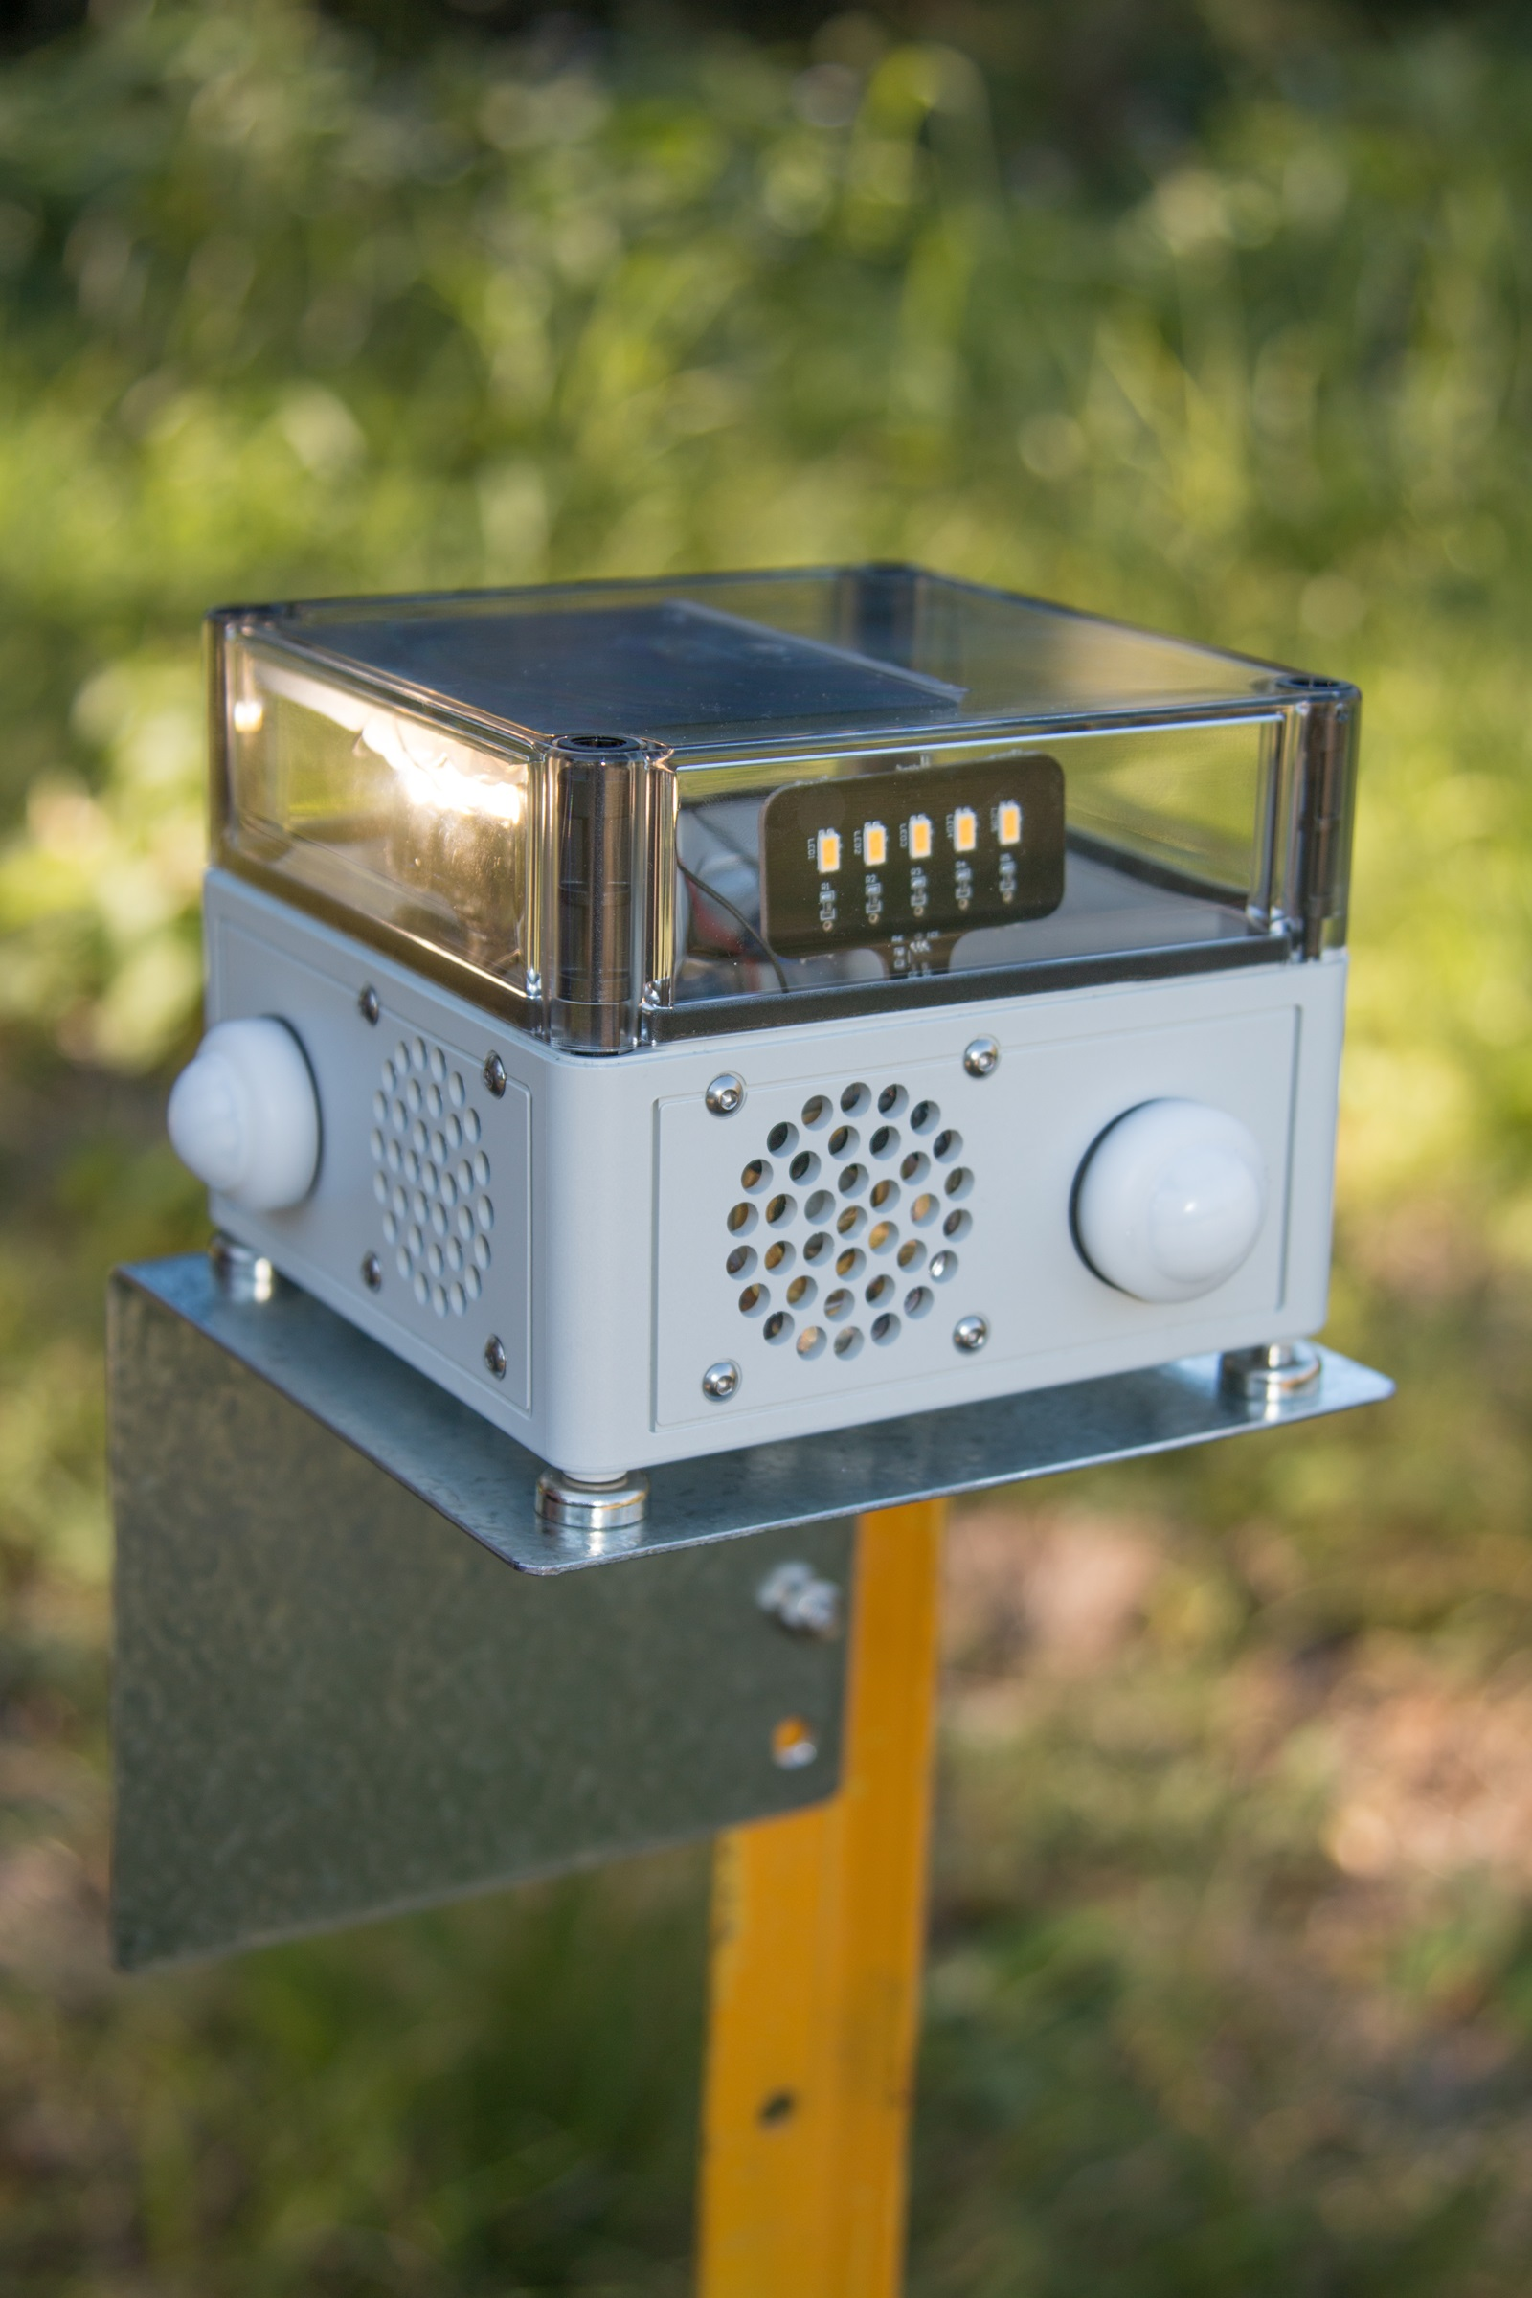

12/4 2 hours

Today I was doing research on both the motion sensor and the wifi modular and decided that because of limited time, I would not be able to finish this project in time if I used the wifi modular. Back to redesigning and this time, it went a lot better and I was able to get started actually working on my project. This time I decided to use the motion sensor, a button, LEDs, and the buzzer to simulate the VPDaD. My design involved the motion sensor setting off the LED which allowed me to know when to press the button to set off both the buzzer and the light by the fields to get rid of the animals nearby. This design was much easier to set up, and actually would be done much quicker. I wanted to set up the motion sensor, and the buzzer/button separately. I figured that if I could get these two things working separately then, I would be able to merge them together easily in the end and left off at this point.

12/5 3 hours

I started today with the motion sensor since it was just one thing instead of both the button and the buzzer together. I started with the hardware, and putting it together was easy with only 3 wires needed to get it together. After putting it together I started coding and researching how to get it to start working. The first way that I coded the motion sensor, caused it to show that there was motion all the time. This was a great setback and took a long time for me to even figure out how to get the serial monitor to stop saying that there was motion, and to get the LED to turn off. After I did finally get that to go off, I could not get the motion sensor to sense any motion at all, and it took so long, that I eventually left off at that point and took off till the next day.

12/6 4 ½ hours

Today started off well because I started working on the Buzzer and the button and everything that I was uploading were actually working. Because there were only 3 wires for the motion sensor, I just took them out completely and started putting together the buzzer/LED and the button on the breadboard and the Arduino. After putting together the hardware I started putting together the code for both the buzzer and the button. As I coded I verified my code frequently to make sure everything was working well and it was working quite well for most of the time. After I finished my code and uploaded what I had, I quickly realized that the buzzer and LED were on all the time and only when I pressed the button would they turn on. I was confused and got a little frustrated about this, so I eventually just gave up and took a day off to think about what was wrong.

12/8 5 hours

Just two days before the project was due, I decided I needed to just put all the code and the hardware together and see if I could fix all of the small issues. Putting the hardware together was easy using the breadboard, but the software was a little different story. I started by just putting everything together and uncommenting everything that I had commented out. I was getting frustrated when I could not figure out why there were so many errors. I did finally get rid of all of the errors and I even got the button and the buzzer working correctly where the buzzer/LED only turned on when the button was pressed. I was not able to get the motion sensor working, but this was after dozens and dozens of reworking the code and finally just being satisfied with what I had. After I was finally done with the Arduino, I decided to make a model for the farmers’ crops and cut out an area where the motion sensor could go and just put the buzzer/LED right on the outside of the model.

Final Thoughts

Overall, I really enjoyed this project and I would love to keep working on perfecting this prototype. The first thing that I would love to do is make the motion sensor work with the wifi modular, or even just have them turn on automatically when the motion sensor goes off. This would be easier and more convenient for the farmer who is controlling whether the light and buzzer goes off or not depending on what the motion sensor is detecting. Going along with that, I would add to the LED and make it blinking to be more effective for getting rid of the pests going into the fields.

Works cited

“New Technology Deterring Crop-Destroying Pest Animals.” *CSIRO*, 12 Nov. 2018, www.csiro.au/en/Research/BF/Areas/Protecting-Australias-agricultural-industries/Robot-technology/Vertebrate-Pest-Detect-and-Deter.

Giancaspro, Dave. “Using Motion Detectors With an Arduino.” *Wired*, Conde Nast, 6 Sept. 2012, [www.wired.com/2012/09/using-motion-detectors-with-an-arduino/](http://www.wired.com/2012/09/using-motion-detectors-with-an-arduino/).

file:///C:/Users/leath/Downloads/The%20Most%20Complete%20Starter%20Kit%20for%20MEGA%20V1.0.17.7.9%20(7).pdf

“How to Use a Buzzer with Arduino.” Ardumotive Arduino Greek Playground, www.ardumotive.com/how-to-use-a-buzzer-en.html.